This assignment is worth 3% of your lab grade. Name:
- This assignment is to help you understand the theory behind selection pressures and differences in communities as a result of different pressures.
- You will be using your results from Activity 6 on the diversity of protists. Using the data collected during your lab, you will need to create a chart similar to the figure below:
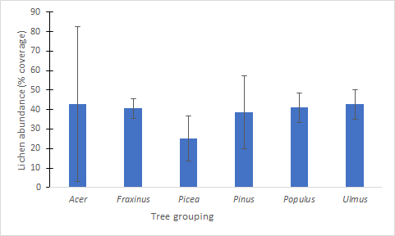
Figure 1: The coverage of lichen (% abundance) on various genera of trees in Edmonton, AB, January 2021. Error bars represent standard error. A total of 104 trees were sampled in the study, where abundance was added from north and south sides quadrats of 201.6 cm². Lichen abundance was not different between the tree genera (F = 0.375, p = 0.865, d.f. = 5, 99). The tree genera (tree grouping) includes native and introduced genera.
- Your chart should meet all the criteria that were provided in the assignment for Activity 4, but this time should include error bars with the standard deviation for each environment.
- You will also use the assigned paper in the Blackboard folder for Activity 6 and your textbook to look at how protists, in general, could be limited by phylogenetic similarities. All information must be paraphrased; quotations will not be accepted.
- You will be graded using the rubric posted in the assignment folder for Activity 4 and must follow the guidelines in “Biology 108 How to Cite”.
- This assignment must be typewritten and double spaced for submission.
Part 1: Results from Activity 6

In 150-250 words, discuss which environment had the greatest richness based on your class data and the analysis of your lab instructor. You should justify your answer using descriptive statistics and the results of the statistical test. You can comment if you notice any differences in species composition and/or evidence for selection pressures between the environments. Include your figure for your results at the end.

Part II: Phylogeny and competitive exclusion and reading scientific literature: Background
This is another chance to read scientific literature. You should read the assigned article by Violle et al. (2011) and the textbook (pages 559-581 - Chapter 24) and discuss how phylogenetic similarity would or would not influence the results you observed in our study of protist richness, citing the article and the text where appropriate. You should use a result from the paper and an example from the textbook to support your argument (maximum of 400 words). Note that it is not necessary to deeply understand the paper to do the assignment, but to have a working knowledge of one of the results.

